FINAL YEAR PROJECT IDEAS

TEAM

Richa Infanta J (22x037)

Jeslyn Nivedhitha S (22x020)

1. Sentiment Analysis
Project Title: "Emotion-Based Feedback Analysis for Educational Content"
Dataset: Create dataset among students using Label Studio
Working:
The project analyzes feedback (textual responses) given by students or users on educational platforms. It classifies sentiments into multiple categories (e.g., happy, frustrated, confused) rather than traditional positive, negative, or neutral labels. It provides actionable insights for educators to improve their content based on detected emotions.
- Libraries: TensorFlow, Keras, NLTK, SpaCy
- Algorithm: Bidirectional LSTM for text classification

2. Speech Recognition
Project Title: "Accent-Aware Voice Command System"
Dataset: Common Voice Dataset by Mozilla
Working:
The system recognizes and processes voice commands, but with an added layer to detect and adapt to accents. It improves accuracy in understanding commands by preprocessing audio to normalize accent differences before processing commands.
- Libraries: PyTorch, Librosa, SpeechRecognition
- Algorithm: Convolutional Recurrent Neural Networks (CRNN)
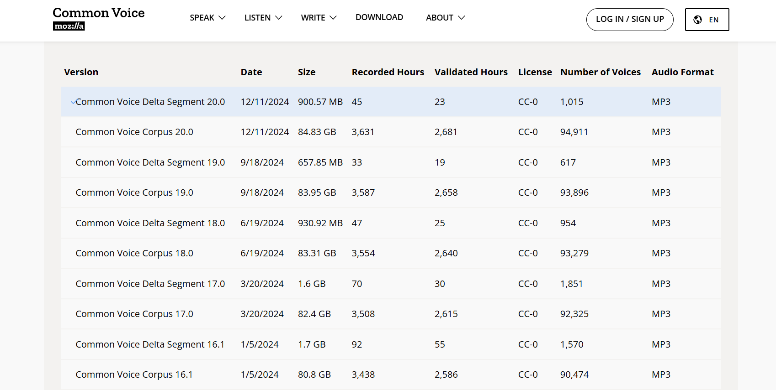

3. Face Recognition
Project Title: "Emotion-Based Attendance System"
Working:
An attendance system that not only recognizes faces but also detects the emotions of students during the attendance process. Teachers can later review emotion statistics (e.g., boredom, engagement) to gauge class engagement.
- Libraries: OpenCV, dlib, TensorFlow/Keras
- Algorithm: Haar Cascade for face detection, CNN for emotion recognition

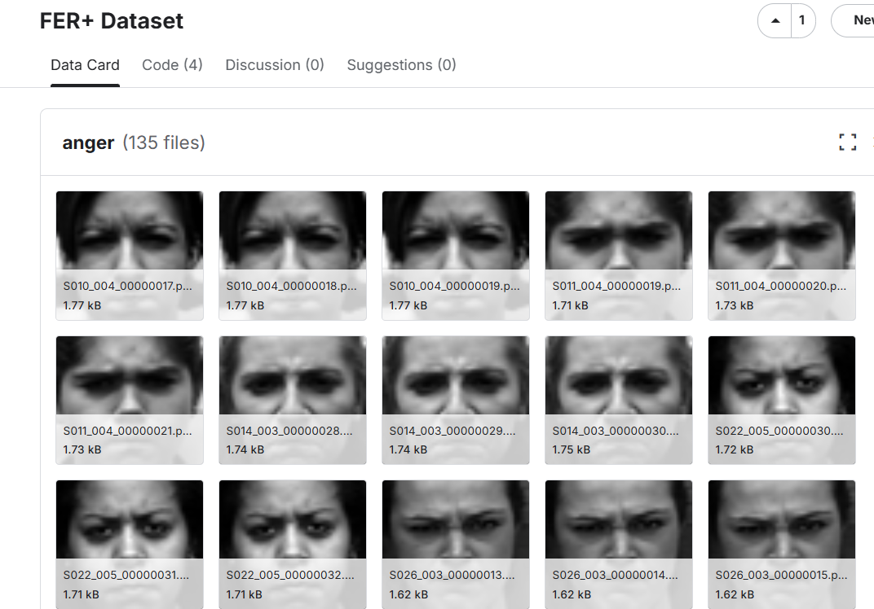

4. Health Related
Project Title: "Chronic Illness Early Detection Using Lifestyle Patterns"
Dataset: UCI dataset (Diabetes)
Working:
The project uses data from wearable devices (or manually input data) like sleep patterns, activity levels, and heart rate to predict early signs of chronic illnesses like diabetes or hypertension. It offers preventive suggestions.
- Libraries: NumPy, Pandas, Scikit-learn, Matplotlib
- Algorithm: Random Forest for prediction

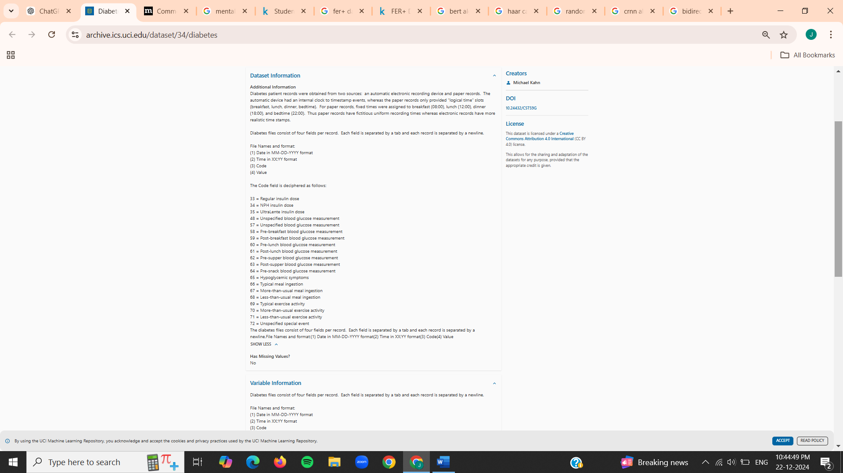

5. Psychology Related
Project Title: "Mental Health Assessment via Cognitive Behavioral Patterns in Text"
Dataset: Kaggle – Mental Health dataset
Working:
The system analyzes users' journal entries or social media posts for cognitive distortions, such as overgeneralization or catastrophizing. It suggests self-help resources or recommends professional consultation based on severity.
- Libraries: NLTK, Gensim, Scikit-learn
- Algorithm: Transformer-based models like BERT for natural language understanding
